**Report**

Subscribers Galore: Estimation of Business Expenses.

Introduction:

Overview & Purpose:

This report delves into the fascinating realm of business expenses and provides

a visual exploration of the various expenditures incurred by different

businesses. It showcases the distribution of expenses, identifies key cost

drivers, and highlights areas of potential optimization or concern. The visual

representations allow for intuitive analysis, facilitating a deeper understanding

of expenditure patterns and their implications for business performance.

Decision-makers, financial analysts, and stakeholders can gain valuable insights

into the financial health of businesses, identify areas of inefficiency or

opportunity, and make informed decisions to optimize resources and drive

growth. To Extract the Insights from the data and put the data in the form of

visualizations, Dashboards and Story we employed Tableau tool.

**Problem Definition & Design Thinking:**

**Empathy Mapping:**

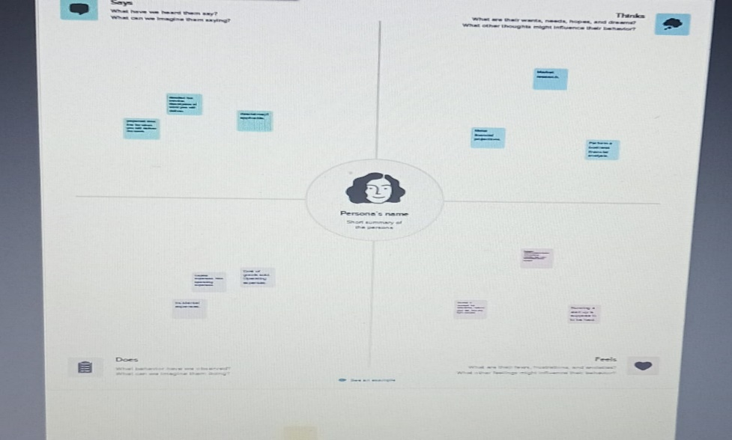

**Brainstorming:**

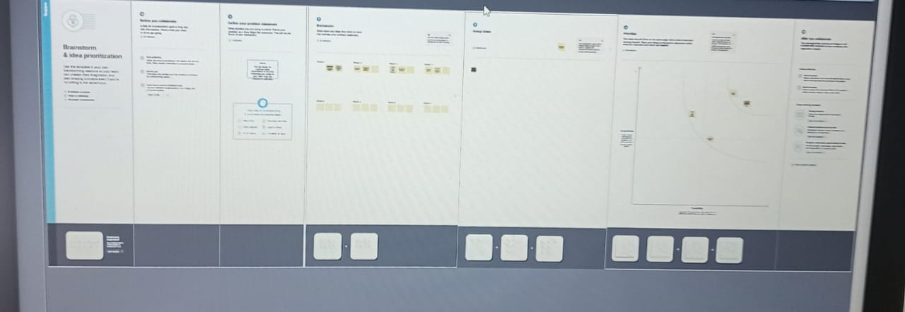

**Result:**

**Story:**

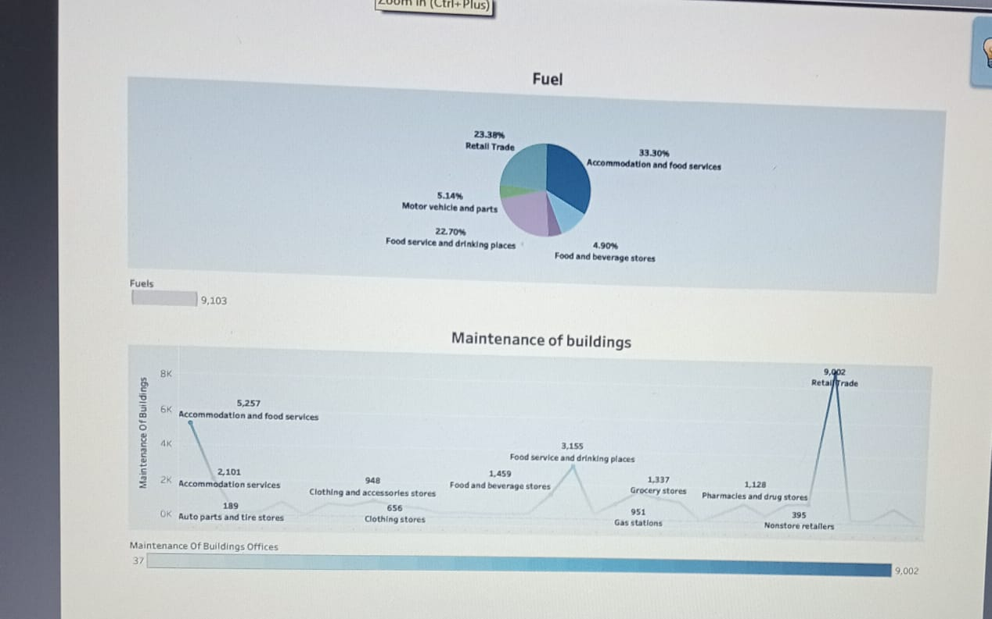

**Dashboard 1:**



**Dashboard 2:**

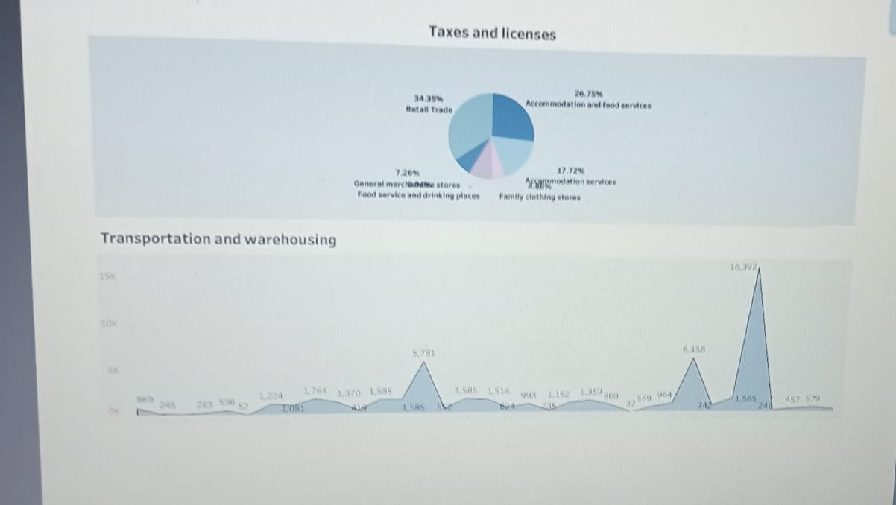

**Dashboard 3:**

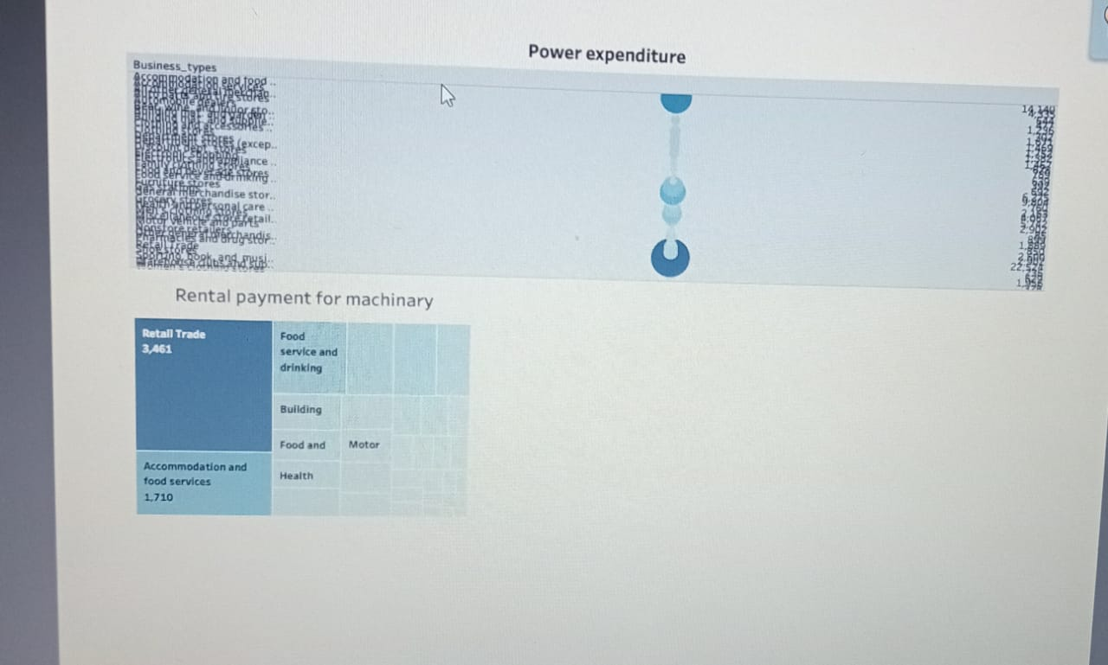

**Dashboard 4:**

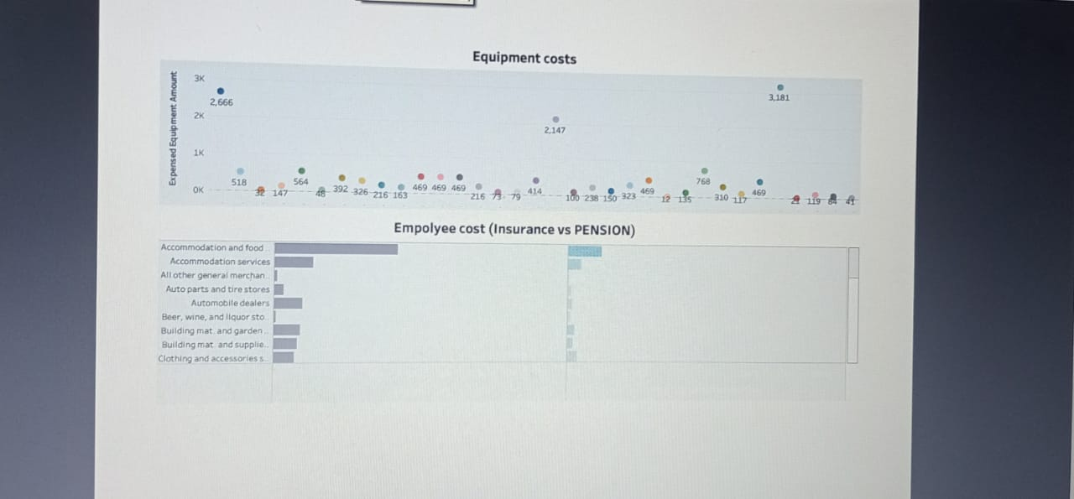

**Dashboard 5:**

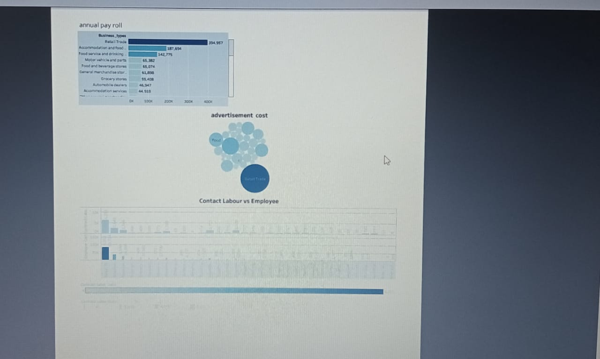

**Conclusion:**

**We have compared business with subscribers, low initial estimates, externa factors, to set**